

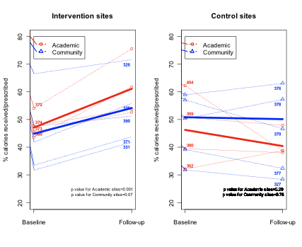


Study Rationale

Several observational studies have described an association between inadequate feeding and poor clinical outcomes in critically ill patients (1-3). Despite repeated efforts to improve the amount of calories delivered via the enteral route, nutrition therapy remains suboptimal in the ICU (4-6). If we are to be successful at increasing the provision of calories and protein via the enteral route, a new paradigm is required. Historically, feeding protocols have been used to guide the delivery of enteral nutrition (EN) but they frequently utilize conservative, reactionary approaches to optimizing nutrition. For example, enteral feeds are started at low rates, are advanced slowly, and maintained at a target maintenance rate with no provisions to compensate for loss of feeding time due to frequent interruptions. Moreover, motility agents are only initiated after manifestations of delayed gastric emptying develop. The result is a form of iatrogenic malnutrition in which critically ill patients consistently receive less than their prescribed nutritional needs.

The PEP uP Protocol

We propose a new approach that protocolizes an enhanced approach to providing EN and shifts the paradigm from reactionary to proactive followed by de-escalation if nutrition therapy is not needed. Please see next page for a list of the key components of this new protocol.

Nurses Education

Since the bedside nurses initiate and utilize feeding protocols to achieve target goals, we will couple this newer generational feeding protocol with a comprehensive nurse-directed nutritional educational intervention that will focus on its safe and effective implementation. This focus on nursing nutrition education represents a major shift away from traditional education which has focused on dietitians and physicians.

The PEP uP Cluster Randomized Controlled Study

In 2010-2011, 18 sites from the US and Canada participated in a cluster randomized controlled trial, to evaluate the PEP uP Protocol and nursing education package. Use of the PEP UP protocol resulted in significantly more total protein (47.0 vs. 33.5 %, p<0.0001) and calorie (42.7 vs. 31.9 %, p<0.0001) delivery than compared to baseline and compared to the control group in the follow up phase (47.0 vs. 33.5 %, p=0.003 for protein, 42.7 vs. 33.4 %, p=0.006 for calories). There were no differences in complication rates, and nurses considered the protocol to be safe and easy to use.

NIBBLE
Nutrition Information Byte
Brought to you by www.criticalcarenutrition.com and your ICU Dietitian
Enhanced Protein-Energy Provision via the Enteral Route Feeding Protocol in Critically Ill Patients:
The Protocol
Issue 7
NIBBLE
Nutrition Information Byte
For more information, please contact Lauren Murch at murchl@kgh.kari.net, or visit www.criticalcarenutrition.com.
Thanks for nibbling on our NIBBLE.

