

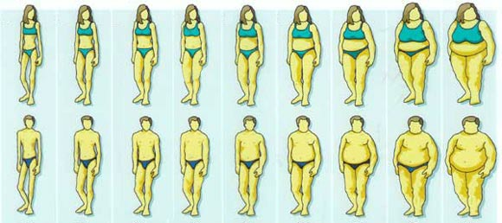
In a recent ARDSNET randomized trial published in JAMA, investigators compared the effects of trophic feeds (for the first 6 days, received only 25 % of goal calories) vs. full enteral feeding (up to goal rate as quickly as possible, received about 80% of goal calories) in 1000 critically ill patients with lung injury (1). This trial was part of a 2x2 factorial trial where patients were also randomized to omega 3 fatty acids or a control solution. The use of a calorie containing active ingredient and a protein containing control solution in the OMEGA trial confuses the interpretation of the EDEN trial, but nevertheless the investigators reported no difference between trophic vs. full feed patients in terms of ventilator-free days, infections, and 60-day mortality. How could that be? Particularly, since we have recently shown that better nutritional intake (>80% caloric intake) is associated with improved mortality in a large observational study (2).

To properly interpret this study, one has to remember that not all critically ill patients are the same in terms of their nutritional risk or the benefit they receive from artificial nutrition. The evidence for this assertion comes from studies that demonstrate a differential treatment effect of artificial nutrition in different subgroups of ICU patients. In a recent analysis we observed that an increase of 1000 calories per day was associated with an overall reduction in mortality (Odds Ratio for 60 day mortality 0.76, 95% Confidence Intervals [CI] 0.61-0.95, p=0.014) (3). However, the beneficial treatment effect of increased calories on mortality was observed in patients with a BMI<25 and >35 with no benefit for patients in the BMI 25 to <35 group. Similar results were obtained when comparing increasing protein intake and its effect on mortality in different BMI groups. Subsequent to our publication, a group of French investigators confirmed these observations in a small group (n=38) of critically ill patients requiring prolonged mechanical ventilation (4). They identified that in this severely ill population an energy deficit of approximately 1200 kcals/day is associated with an independent likelihood of ICU death (odds ratio 6.12, 95 %CI 1.33-28.2, p=0.01). Integrating these two studies, we can conclude that patients with low BMI, high BMI, and with prolonged stays in ICU (>7 days) may benefit the most from nutrition therapy, whereas patients in mid-range of BMI or who have short stays will not. In the EDEN trial (1), the patients were young (average 52 yrs), normo-well nourished (average BMI 30), and had a relatively short stay in the ICU (average duration of mechanical ventilation of 5 days). Furthermore, all patients received the benefits of early EN. Hence it is no surprise that the trial did not show a difference between trophic vs. full feeds. It is also important to note that functional endpoints, such as quality of life, physical function, return to work, etc. were not measured and one can postulate that trophic feed patients suffered more erosion of lean skeletal mass and poorer functional outcomes, particularly those older patients who are already sacropenic at the onset of their critical illness.

What this study really speaks to is the need to have better tools that will help discriminate patients that benefit the most from aggressive nutrition therapy (or conversely, those that will be harmed the most by iatrogenic malnutrition). We recently developed a nutrition risk assessment tool validated specifically for the ICU patient population, the NUTrition Risk in the Critically ill Score (NUTRIC Score) (5).

This score was based on a conceptual model that linked starvation, inflammation, nutrition status to clinical outcomes (Figure 1). We considered markers of acute starvation (i.e. decreased oral intake and pre-ICU stay in hospital) and chronic starvation (history of recent weight loss and a low BMI) (5). To represent acute inflammatory markers, we chose PCT, IL-6, and CRP and the presence of comorbid illnesses to reflect a measure of chronic inflammation. All of the variables selected based on the conceptual model were candidates for the inclusion in the NUTRIC score algorithm. We expected this model to explain additional mortality risk, above and beyond what would be derived from use of traditional measures of severity of illness (APACHE II score and baseline SOFA). Based on the statistical significance in the multivariable model, the final score used all candidate variables except BMI, CRP, PCT, estimated % oral intake and weight loss. As the score increased, so did mortality rate and duration of mechanical ventilation. Most importantly, in a subgroup of patients who stayed in ICU more than 3 days, we observed that patients with a high NUTRIC score benefit the most from aggressive provision of protein-energy requirements, towards meeting their estimated requirements. On the other hand, patients with a low score may even be harmed by such an approach. In summary, the NUTRIC score may be used to help determine which patients receive supplemental parenteral nutrition or strategies to enhance EN delivery (such as motility agents, small bowel feeding tubes, and aggressive feeding protocols, such as the PEP uP protocol (6)). The NUTRIC score, or the concepts contained therein, may have utility in the design and interpretation of clinical trials of nutrition therapies in the ICU setting. Studies that include heterogeneous ICU patients, some at high nutritional risk, some at low nutritional risk, are more likely to be negative than those who focus on treating only high risk patients. We believe this to be the case for the EDEN Study as well as for the EPaNIC study of supplemental PN (7) recently published in the New England Journal of Medicine.
NIBBLE
Nutrition Information Byte
Brought to you by www.criticalcarenutrition.com and your ICU Dietitian
Trophic Feeds for All Patients With Acute Lung Injury?
No! Read on…
Issue 7
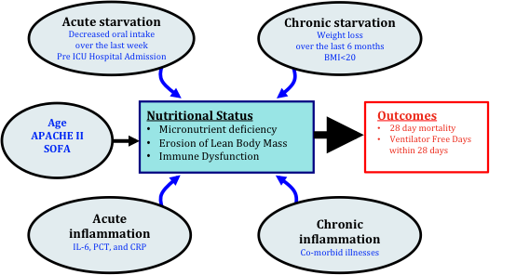
NIBBLE
Nutrition Information Byte
References:
- Rice TW, Mogan S, Hays MA, Bernard GR, Jensen GL, Wheeler AP. Randomized trial of initial trophic versus full-energy enteral nutrition in mechanically ventilated patients with acute respiratory failure. Crit Care Med 2011;29(5):967-974.
- Heyland DK, Cahill N, Day A. Optimal amount of calories for critically ill patients: Depends on how you slice the cake! Crit Care Med 2011 Jun 23 (epub).
- Alberda C, Gramlich L, Jones NE, Jeejeebhoy K, Day A, Dhaliwal R, Heyland DK. The relationship between nutritional intake and clinical outcomes in critically ill patients: Results of an international multicenter observation study. Intensive Care Med 2009;35(10):1728-37.
- Faisy C, Lerolle N, Dachraoui F, Savard JF, About I, Tadie JM, Fagon JY. Impact of energy deficit calculated by a predictive method on outcome in medical patients requiring prolonged acute mechanical ventilation. British J Nutrition 2009;101:1079-1087.
- Heyland DK, Dhaliwal R, Jiang X, Day A. Identifying critically ill patients who benefit the most from nutrition therapy: the development and initial validation of a novel risk assessment tool. Critical Care 2011 Nov 15;15(6):R268 (Epub).
- Heyland DK, Cahill NE, Dhaliwal R, Wang M, Day AG, Alenzi A, Aris F, Muscedere J, Drover JW, McClave SA. Enhanced protein-energy provision via the enteral route in critically ill patients: a single center feasibility trial of the PEP uP protocol. Crit Care 2010;14(2):R78.
- Casaer MP, Mesotten D, Hermans G, et al. Early versus late parenteral nutrition in critically ill adults. N Engl J Med 2011. DOI: 10.1056/NEJMoa1102662.

Figure 1. Conceptual Model For Nutrition Risk Assessment in the Critically Ill
For more information, please contact Lauren Murch at murchl@kgh.kari.net, or visit www.criticalcarenutrition.com.
Thanks for nibbling on our NIBBLE.

