


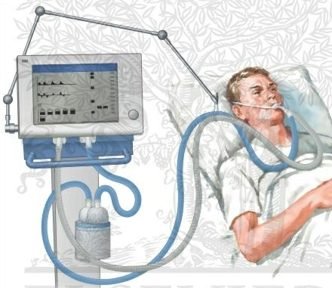

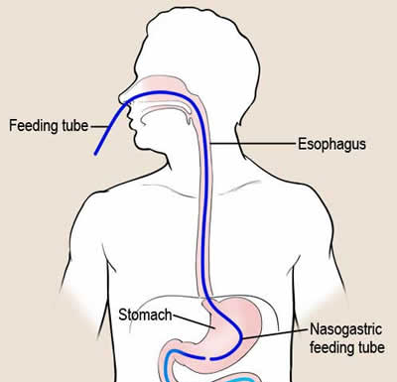


There is some concern about the safety and efficacy of feeding hemodynamically unstable patients. We are not advocating feeding patients who are not fully resuscitated (as evidenced by rising lactate and escalating dose of vasopressors). Having said that, being on vasopressors is NOT a contraindication to enteral feeds. There is some evidence from animal studies that early EN has a positive effect on intestinal blood flow (1,2). In hemodynamically unstable critically ill patients, there is some evidence that nutrition gets absorbed and metabolized with no worsening effect on systemic measurements of oxygenation and perfusion (3).

Most importantly, there was a very recent large scale, multicenter, observational study that studied mechanically ventilated, vasopressor dependent patients and classified them as to whether they were fed within the first 48 hours (early group) or after 48 hours (after group). They used sophisticated statistical strategies (propensity scores) to adjust for potential confounding variables and showed that vasopressor dependent patients fed early had a significant survival advantage compared to the delayed group (4). Moreover, in a subgroup analysis, they even demonstrated that the sickest patients (on multiple vasopressors compared to those on one vasopressor only) had a significant survival advantage. Although this is not a randomized trial and there are no such trials that address this question specifically. Thus, the best evidence to date that supports the use of enteral feeding in vasopressor dependent patient.
It may be worth printing this article, giving it a read, and sharing it with your physician colleagues!

NIBBLE
Nutrition Information Byte
Brought to you by www.criticalcarenutrition.com and your ICU Dietitian
Should We Enteral Feed Patients That Are Hemodynamically Unstable?
Issue 3
For more information, please contact Lauren Murch at murchl@kgh.kari.net, or visit www.criticalcarenutrition.com.
Thanks for nibbling on our NIBBLE.
References:
- Purcell P, Davis K, Branson R, Johnson D. Continuous duodenal feeding restores gut blood flowan increases gut oxygen utilization during PEEP ventilation for lung injury. Am J Surg. 1993 Jan;165:188-94.
- Kazamias P, Kotzampassi K, Koufogiannis D. Influence of enteral nutrition-induced spalanchnic hyperemia on the septic origin of spalanchnic ischemia. World J Surg. 1998;22:6-11.
- Revelly J, Tappy L, Berger M, Gersbach P, Cayeux C, Chiolero R. Early metabolic and spalanchnic responses to enteral nutrition in postoperative cardiac surgery patients with circulatory compromise. Intensive Care Med. 2001;27:540-7.
- Khalid I, Doshi P, DiGiovine B. Early enteral nutrition and outcomes of critically ill patients treated with vasopressors and mechanical ventilation. Am J Crit Care. 2010 May;19(3):261-8.
You can feed patients how you normally feed everyone else (start at 25 ml/hr and slowly ramp up). However, being on vasopressors is also a risk factor for developing GI intolerance (as manifested by high gastric residual volumes) so a potentially safer alternative strategy would be as follows:
- Start ‘trophic’ or ‘trickle’ feeds: 10-20 cc/hr of a semi-elemental, concentrated solution within the first 24-48 hours after ICU admission.
- Just leave it at that rate (don’t escalate) for 24 hours and then reassess.
- Monitor the patient for tolerance (abdominal distension, rising lactate, gastric residual volumes, etc.)
- If the patient is tolerating that minimal amount and the clinical condition is improving, start to ramp up the feeding rate or even change to a polymeric solution the next day.
Key points:
- Resuscitation is the priority
- No sense in feeding someone dying of progressive circulatory failure
- If on stable or declining doses of vasopressors, early enteral feeding may be beneficial
- Adopt strategies to maximize the benefits and minimize the risks associated with early enteral nutrition (e.g. trophic feeding)

