


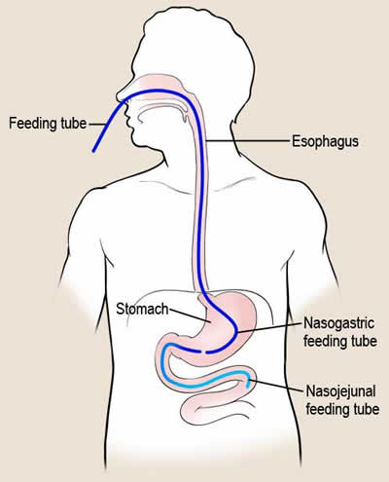
High NG drainage or large gastric residual volumes are a manifestation of delayed gastric emptying. As a class of drugs, motility agents do improve gastric emptying, helping to improve tolerance to enteral feeding and thereby increasing nutritional adequacy (reducing the caloric debt). Theoretically, they could decrease reflux and aspiration pneumonia by keeping things moving forward but this has not been shown to date.

Depending where in the world you work, you may be limited to only a few therapeutic options: Metoclopramide 10 mg IV q 6 h (half the dose in renal failure) or Erythromcyin 200 mg (or less) q 12 h IV. These drugs can be used prophylactically in high risk patients (start them when starting feeds if you expect problems) or reactively, when you encounter a high gastric residual volume. They can be used alone, in sequence (try one then the other), or you can achieve maximal effects used in combination¹. These drugs do have side effects so discontinue them if they are not needed (patient now tolerating their feeds) or if they are not working (refractory high gastric residual volumes).
Is it worthwhile going to the effort of placing the feeding tube into the small bowel?

In patients experiencing persistent high gastric residual volumes, placing a feeding tube into the small bowel will enable you to overcome this problem in the majority of cases. You can better deliver enteral nutrition via a small bowel tube when the stomach is not emptying properly. Ideally, this tube should be placed into the jejunum, not just beyond the pylorus. Some patients with the tube just beyond the pylorus will still experience duodeno-gastric reflux and this may put them at risk for developing ventilator-associated pneumonia (VAP). To minimize the risk of aspiration, you have to bury the distal tip of the feeding tube as far down as you can get it².

By the way, did you see the meta-analysis from the Canadian guidelines of small bowel vs gastric feeding? You can see it on our website and it includes the recent trials on this subject. It suggests that feeding distally in the small bowel is associated with a significant reduction in the development of VAP. So, if your patient is at high risk for VAP (for example, has to be nursed flat or unable to elevate head of bed) or if your patient is having trouble tolerating enteral nutrition despite use of motility agents, place the feeding tube into the small bowel!

NIBBLE
Nutrition Information Byte
Brought to you by www.criticalcarenutrition.com and your ICU Dietitian
Strategies to Deal with GI Intolerance
Issue 2
For more information, please contact Lauren Murch at murchl@kgh.kari.net, or visit www.criticalcarenutrition.com.
Thanks for nibbling on our NIBBLE.
References:
- Nguyen NQ, Chapman M, Fraser RJ, Bryant LK, Burgstad C, Holloway RH. Prokinetic therapy for feed intolerance in critical illness: One drug or two? Crit Care Med 2007;35(11):2561-2567.
- Heyland DK, Drover J, MacDonald S, Novak F, Lam M. Effect of post-pyloric feeding on gastroesophageal regurgitation and pulmonary microaspiration: Results of a randomized controlled trial. Critical Care Med 2001;29:1495-1501.
In the International Nutrition Survey in 2009, on average, 66% of individuals with high gastric residual volumes received motility agents. The best sites provided motility agents to these patients 100% of the time, and the lowest performing sites never gave motility agents to these patients.
In the International Nutrition Survey in 2009, on average, 12% of patients with high
gastric residual volumes received small bowel feeds. The best performing ICUs provided small bowel feeds to these patients 100% of the time, and in the lowest performing ICUs, these patients never received small bowel feeds.

