Feeding Your Family Member in the ICU
This brochure tells you about feeding your family member while he/she is in the Intensive Care Unit (ICU). It contains information about
- Why your family member may need nutrition therapy
- Types of nutrition therapy
- Giving food directly into the stomach or bowel
- Giving food directly into a vein

Why your family member may need nutrition therapy
Due to the stress of their illness your family member is at risk of becoming undernourished. Nutrition therapy is used to give nutrition to people in the ICU because they cannot eat food normally. Providing people with the correct amount and type of nutrition while in the ICU improves wound healing, boosts the immune system, reduces the risk of infection, and helps the stomach work more effectively, which together helps survive their illness and to get better more quickly. Most sick patients in the ICU will receive standard nutrition (protein, carbohydrates, and fats) from either tube or intravenous feeding (described below). However, some patients, depending on their underlying illness should receive specialized nutrients (like glutamine, high dose vitamins, and fish oils) to help them recover from their illness.

Types of Nutrition Therapy
Your family member may have liquid food given through:
- a tube into the stomach or bowel or
- through a drip directly into the bloodstream (intravenously).

Giving food directly into the stomach or bowel

This is called 'enteral nutrition (or enteral feeding)' and means being fed with specially prepared liquid feeds through a tube into the stomach or small intestine. Different formulas are available. The dietitian in the ICU will choose the most appropriate one for your family member, depending on their particular needs. The feeds are usually delivered over 24 hours at a low rate. At first your family member may need to take all their food and drink through these tubes. But as they get better they may take some food by eating normally and the rest as liquid through the tube. The dietitian will decide how much feed your family member needs and the timings.
Enteral feeding is only suitable for people whose digestive tract (stomach and intestines) is working normally. This is because the feeds still go through the usual path of digestion. It is not suitable if your family member has a problem with their digestive tract (e.g. a blockage in the bowel).

Enteral feeds can cause side effects. One potential complication is gastric reflux and aspiration. This is when the contents of the stomach, including feeds, move backwards into the esophagus and are inhaled into the airway and lungs. In some cases, this may cause pneumonia. Your family members’ health care team will take steps to help reduce the risk of reflux and aspiration. These are as follows:
- drugs to increase the rate of stomach emptying
- monitoring the volume of the stomach contents
- raising the head of the bed
- putting the feeding tube down farther into the intestines (see nasojejunal tubes below)

There are several types of tubes for enteral feeding, including
- Nasogastric tubes (NGT)
- Nasojejunal tubes (NJT)
- Gastrostomy tubes

Nasogastric and Nasojejunal tubes
This is the most common type of feeding tube used in the ICU. A nasogastric tube is a thin tube that is put into your family members’ nose and down their throat into their stomach, as seen in the diagram below. It is usually used if they need feeding for less than 3 weeks. A nasojejunal tube (NJT) may also be used. A NJT is like a nasogastric tube but the tip goes into the first part of the bowel (the jejunum). NJTs are used
- When the stomach cannot empty properly
- To get past a blockage in the small bowel
- If your family member had a condition affecting their pancreas
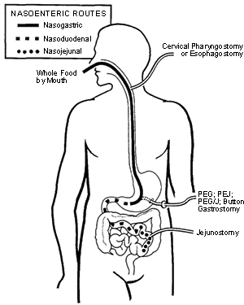

Gastrostomy tubes
A gastrostomy tube goes into the stomach through an opening made on the outside of the abdomen. This type of tube is used for people who have long term problems with eating and swallowing. A gastrostomy tube can be placed by special procedures in the ICU.

Giving food directly into the bloodstream (intravenously)
This is called ‘parenteral nutrition’ (PN). This means being fed directly into the bloodstream through a drip into a vein. The feeds don't go through the normal digestive system. Your family member may have PN through a central line or a line called a “PICC line”. A PICC line goes up a blood vessel in their arm and into a chest vein. Other types of central lines go into the chest and directly into a major blood vessel, as this diagram shows:
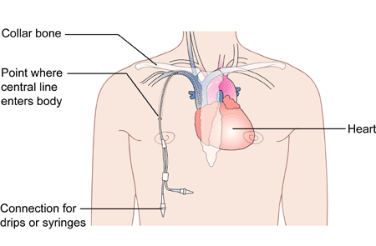
In the ICU, your family member will likely need a central line inserted for treatment procedures other than PN. There can be complications. Sometimes lines get infected or blocked and have to be taken out and replaced.
Your family member is only likely to need PN feeding when his or her gut is not working. For example, if they
- Have severe problems with their stomach or intestine, or if these have been removed.
- Have severe nutritional problems before surgery and can't have enteral feeding.
- Have a hole (fistula) in their stomach or esophagus.
- Are losing a lot of weight or not coping well with enteral feeding.
The solutions used for PN are very complex and are carefully made up in a sterile room each day by a pharmacist. Doctors and dietitians advise the pharmacist about your family members’ specific nutritional needs each day. They will monitor your family member very closely while they are having PN. Your family member will need daily blood tests to check that their blood levels of potassium, sugar, sodium, etc. are normal. PN can have side effects, such as causing a high blood sugar level or affecting the way their liver works. When it is time for your family member to stop having PN feeds, their doctors and dietitian will very gradually reduce the feeds over a few days.
Oral Nutrition
If your family member is awake and can swallow safely, they will be encouraged to eat small meals, energy dense snacks, and nourishing drinks.

What can you do to help with feeding your family member?
1. Be prepared to answer questions about your family members nutritional status prior to their illness, for example:
- What is their height and usual weight?
- Have they lost weight recently?
- Had they been eating normally over the past week or had they lost their appetite?

2. Ask about your family members’ nutrition in the ICU. If they are not eating or being fed ask:
- Why they are not being fed?
- When will they receive food?
- How will nutrition be provided?
- Are there any special nutrients that can be used to treat their illness (such as glutamine, high dose vitamins, fish oils, etc.)?

3. Once feeding has been established (after 2-3 days), ask the nurse if your family member is getting enough nutrition by asking:
- Are they tolerating their feeds?
- Have they reached their goal rate?
- Is the head of the bed elevated?

4. If you are concerned about your family members’ nutrition while in the ICU, you may ask to see a dietitian for advice.
5. If your family member is able to eat, check with the nurse or dietitian what foods are appropriate to bring in for them, and encourage them to take small amounts frequently.

