- Select “Add/Edit Records” to add a new participant.
- Select the “Add new record” button.
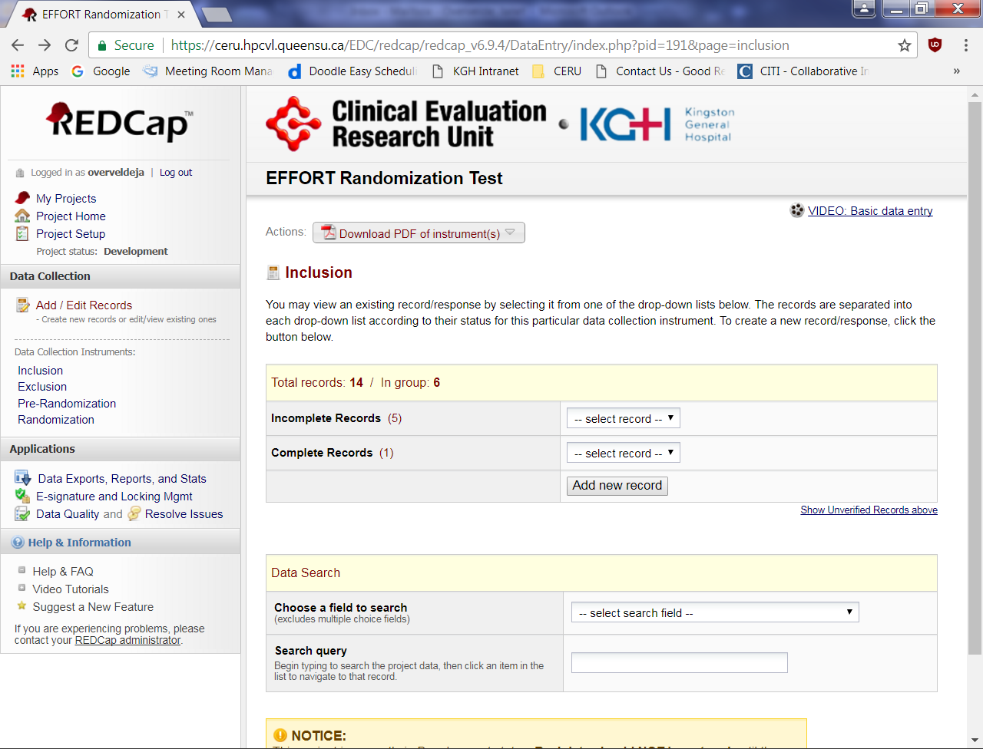
1
2

- The “Inclusion Criteria” form is the first form to be completed. Enter the date you screened the participant and then select “yes or no” to note the presence of each of the inclusion criteria.
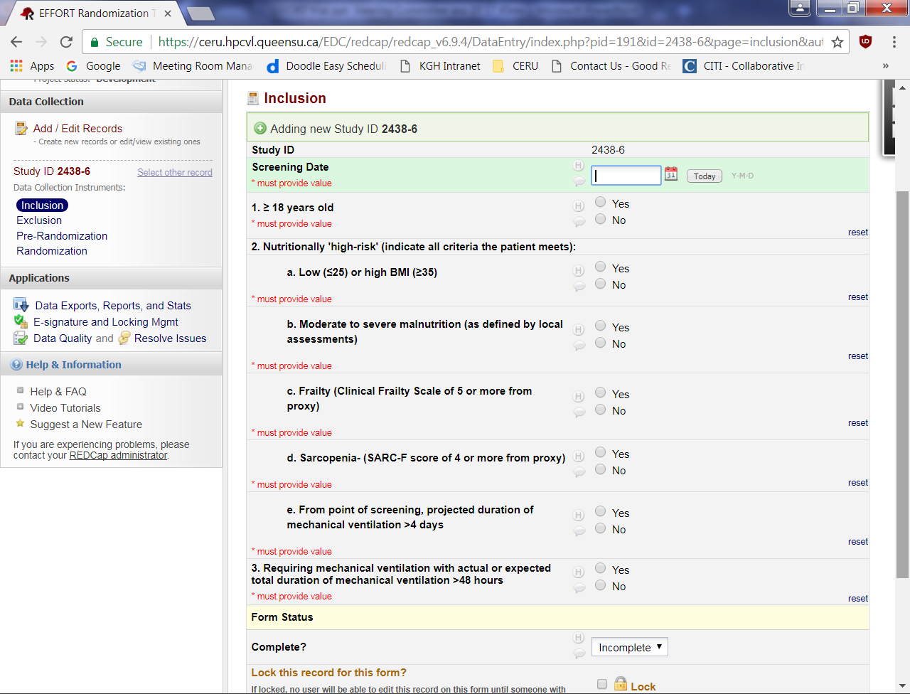
3
4

- Once the data is entered select the “Save and go to Grid” button. NOTE: you will not be able to proceed further until all reminders found in red text are addressed. If you try to save the form with reminder messages still present on the form you will see a message similar to the one below. Select “Okay” to resolve the reminder messages.

- The “Exclusion Criteria” form is the next form to be completed. Select “yes or no” to note the presence or absence of each of the exclusion criteria.

If you say “yes” to at least one exclusion criteria, the participant is not eligible for the study. Simply save the data in this form and the participant will have a status of excluded. There is not further data entry required.

If all of the exclusion criteria are absent, the participant is eligible for the study.

- Select “Save and go to Grid” button.

- If the participant is eligible for the study, the “Pre-Randomization” form is the next form to be completed. On this form, you will be asked the following:

  - Confirm eligibility of the participant with the site investigator. Enter the name of the investigator.
  - Specify the type of consent used (i.e. waived, standard or third-party).
  - Enter the date and time consent was obtained.

If consent is obtained, the participant will be randomized to the study.
- If consent was not obtained because either the SDM was not approached or they were approached but declined, enter those details.
  - If ‘Not approached’ for consent, specify the reason why from the taxonomy provided.
  - If approached for consent but consent was declined, specify the reason from the taxonomy provided.
If consent is not obtained, the participant is eligible but not randomized. Simply save the data in this form and the participant will have a status of excluded. There is not further data entry required.
- Select “Save and go to Grid” button.
- On the “Randomization” form, select the “RANDOMIZE” button.

- REDCap will then perform the randomization and assign the participant to a treatment group. Print this form and add it to your study file.

